Infy Bank wants to conduct examinations for the post of Probationary Officers, Assistants, and Special Cadre Officers. It has rolled out an online application which is available on the Bank’s website. The applicants can fill in the application form and submit it with accurate details.

Assuming that each **Applicant** is represented by the following class diagram:

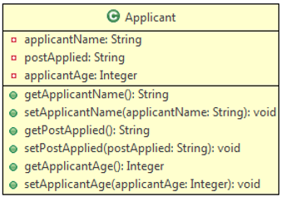

Define an user-defined Exception  **InfyBankException** according to following class diagram:

//code

class InfyBankException extends Exception{

public InfyBankException(String message){

super(message);

}

}

//

Design a **Validator**class which has methods for validating applicant details according to the following class diagram:

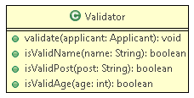

**Method Description:**

* **validate(Applicant applicant):**
  + This method receives the Applicant and calls the respective methods to validate the values. If validation fails, it throws user-defined exceptions **InfyBankException** with the exception message as given below:
  + 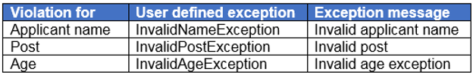

         If all values are valid print the following message:

All the values are valid.

* **isValidApplicantName(String name):**
  + This method validates applicantName.
  + It cannot be null or empty.
  + If the rule is violated then it should return false else it should return true.

* **isValidPost(String post):**
  + This method validates the post the applicant applied for.
  + It should be one among one of the following posts: “Probationary Officer”, “Assistant”, or “Special Cadre Officer”.
  + If the rule is violated then it should return false else it should return true.

* **isValidAge(Integer age):**
  + This method validates the age of the applicant.
  + It should be greater than 18 years and less than 35 years.
  + If the rule is violated then it should return false else it should return true.

Create a class **Tester**and implement it as shown below:

1. Create an object of the Applicant class and populate it with values.

2. Invoke validate() method of Validator class to validate the values.

3. If any exception is thrown, catch the exception and print the exception message.

Note: You can change the input as needed to get a different output.

**Sample:**

**Input:**

|  |  |
| --- | --- |
| **Name** | Jason |
| **Post** | Assistant |
| **Age** | 37 |

**Output:**

Invalid age exception